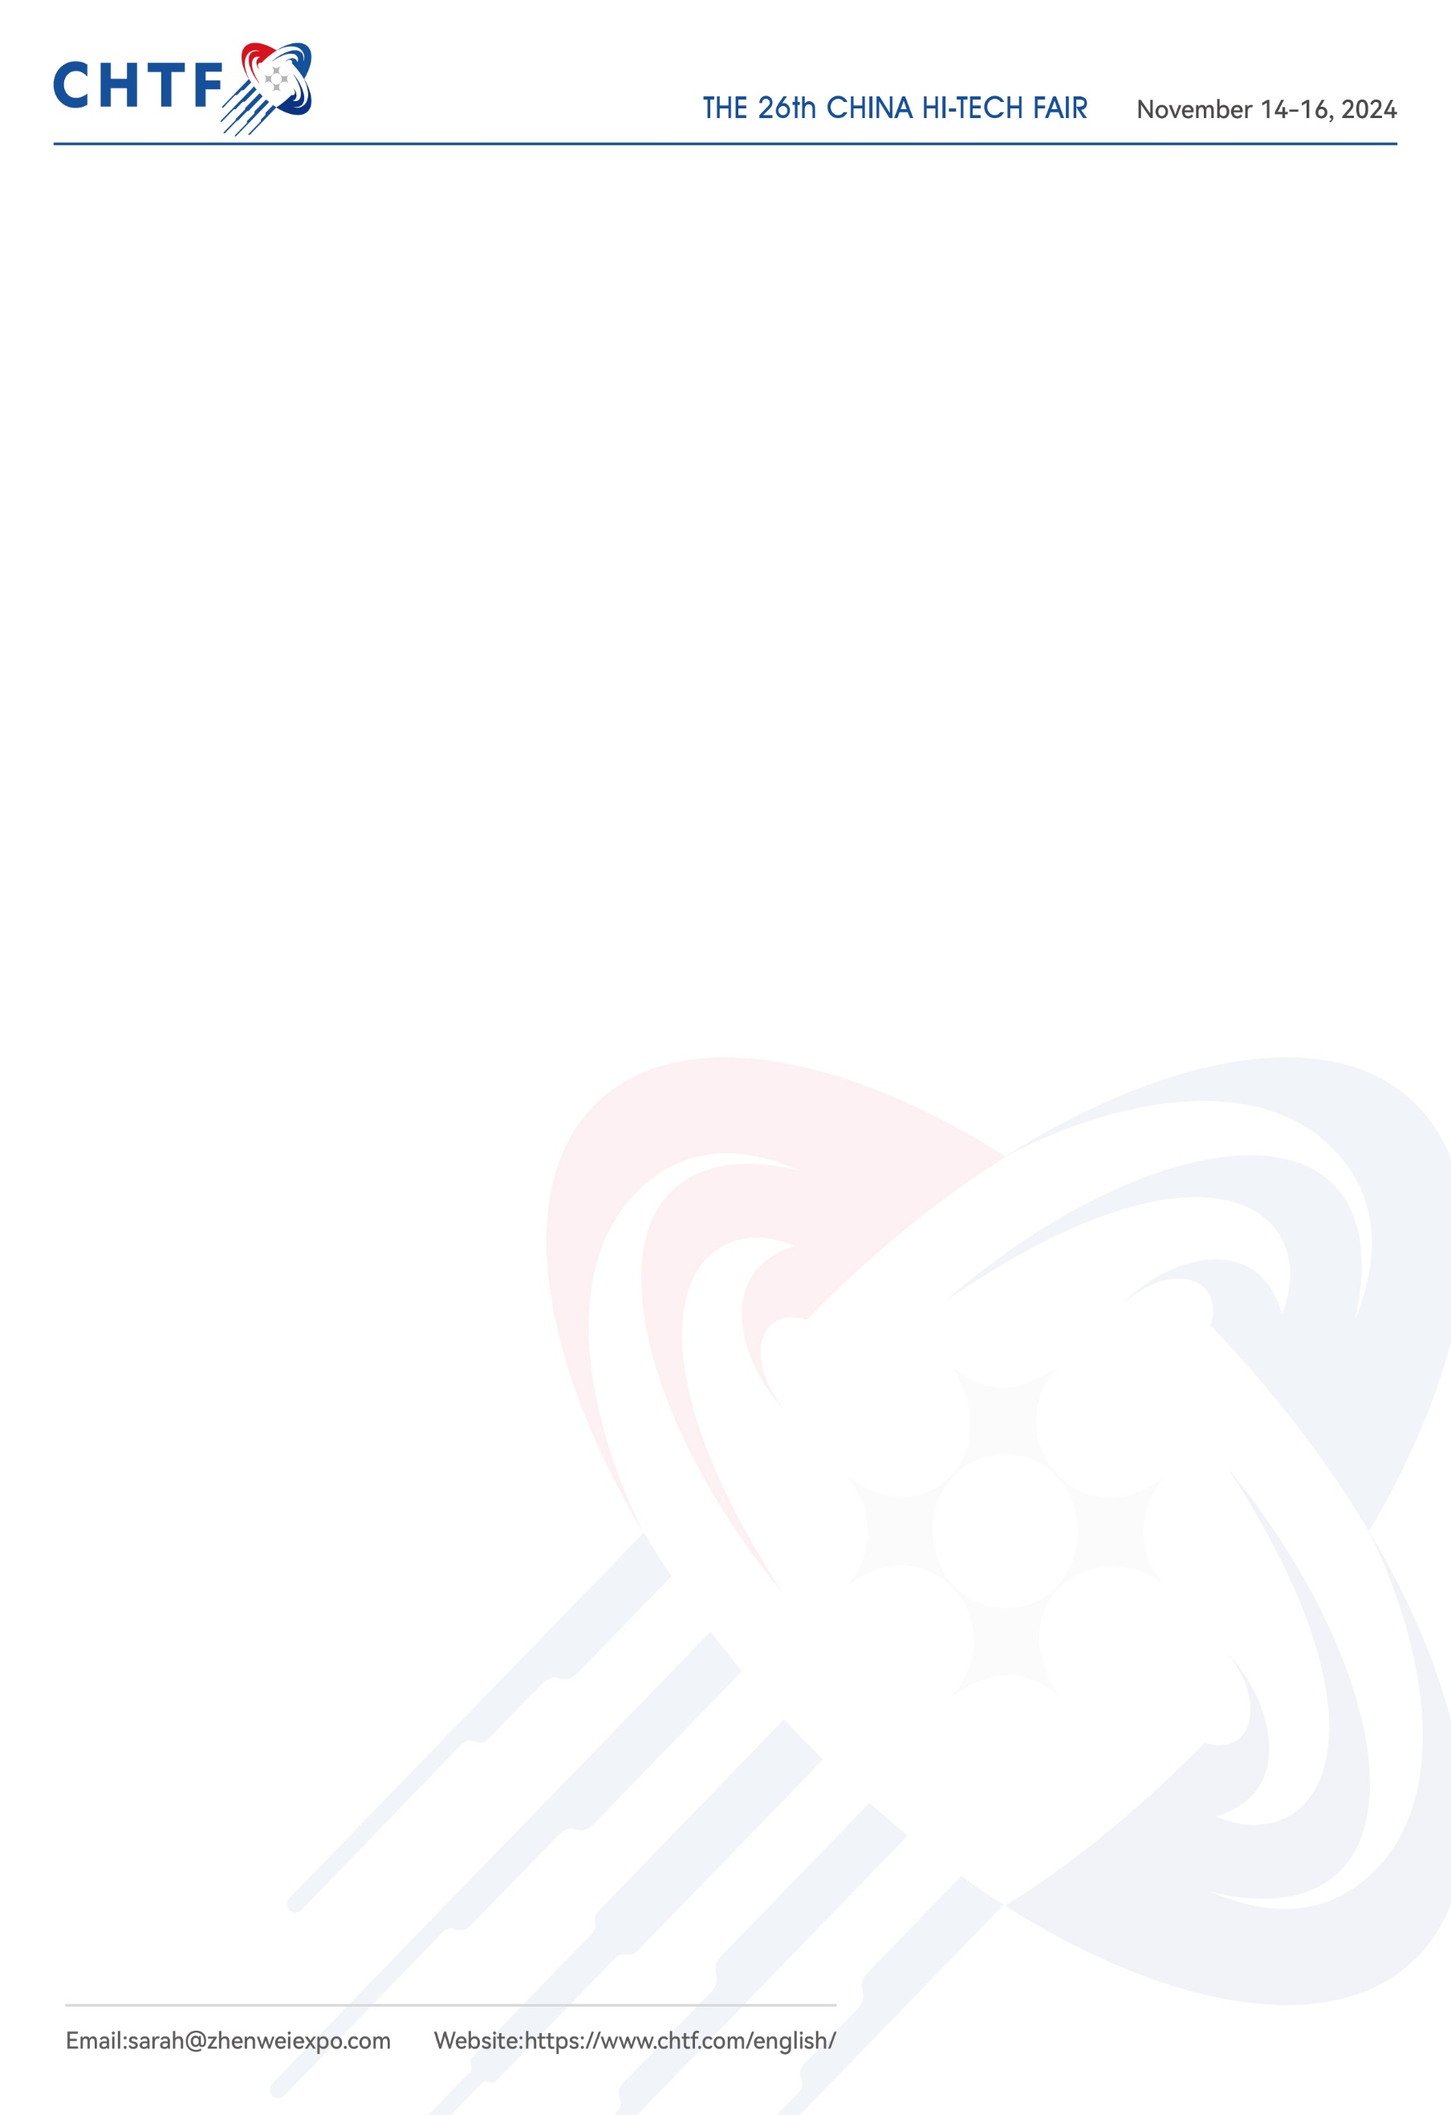**第二十六届中国国际高新技术成果交易会邀请函**

**Invitation from the 26th China Hi-Tech Fair**

第二十六届中国国际高新技术成果交易会将于2024年11月14-16日在深圳国际会展中心（宝安）举办。中国国际高新技术成果交易会（简称高交会）,从1999年至今已经成功举办25届。“科技立国，国运所在，国脉所系，国昌所依。”高交会是中国高新技术领域历史最长、最具影响力的国际性科技盛会。在此，我们诚挚地邀请您前来参观！

The 26th China Hi-Tech Fair (CHTF) is scheduled to be held on November 14-16，2024 in Shenzhen World Exhibition & Convention Center，Shenzhen City, Guangdong Province, China. CHTF has been running for 25 years in a row in Shenzhen since 1999 and is the longest and most influential international science and technology event in China's high-tech field. Hereby, we sincerely invite you to attend the forthcoming CHTF.

**受邀人信息Information of the Invitees:**

**公司/机构名Company Name:**

|  |  |  |  |  |  |
| --- | --- | --- | --- | --- | --- |
| **序号**  **No.** | **姓名**  **Name** | **护照号**  **Passport No.** | **国籍**  **Nationality** | **出生日期**  **Date of Birth** | **性别**  **Sex** |
| 1 |  |  |  |  |  |
| 2 |  |  |  |  |  |
| 3 |  |  |  |  |  |

受邀人将于 2024 年 月 日来华，预计停留 天。受邀人将自行负责往来费用。

The invitees will come to China on and estimated to stay for about days. All attendees will be responsible for all expenses pertaining to cost associated with the visit to and from China.

商祺

Sincerely yours

王丽艳/Sarah Wang

国际观众客服经理/International Visitor Service Manager

独家运营单位/Organizer: 深圳振威国际展览有限公司

Shenzhen Zhenwei International Exhibition Co., Ltd

手机/Mobile:0086-15130613049

邮箱/Email: sarah@zhenweiexpo.com

座机/Tel: 0086-755-85242014

地址/ADDRESS: 深圳市宝安区福海街道新和社区宝安大道6099号星港同创汇天枢座705

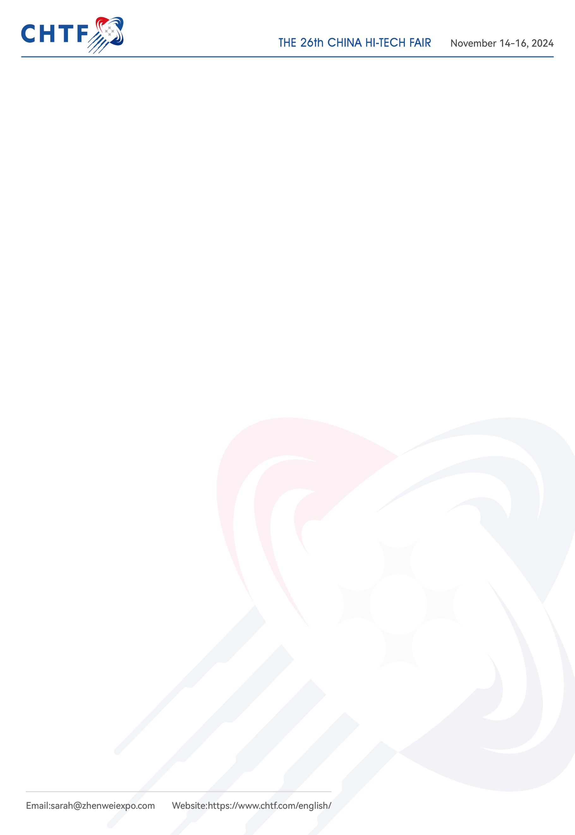Room 705, Tianshu Building, Xinggang Tongchuanghui, NO. 6099, Baoan Avenue, Baoan District, Shenzhen City, Guangdong Province, China

展会网址Event Website: https://www.chtf.com/english/

公司网址Company Web: [www.zhenweiexpo.com](http://www.zhenweiexpo.com)